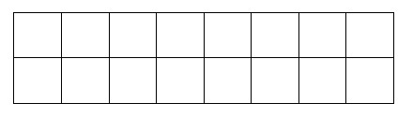

Sujet de Travaux Dirig´es / Pratiques - TP MRF - IMA203

Only one paper document per 2 people.

BUT one jupyter notebook on e-campus for each student.

NAME :

NAME :

In tro d u c tio n to M arko v R a n d o m F ie ld s

for im a g e pro c e ssin g

Objective of the session :

The aim of this session is to program the Gibbs sampler algorithm and study it in the binary

case. This program will then be used to do image classiﬁcation in a bayesian framework (next

practical work).

You have to ﬁll by hand-writing the printed version of the practical work (this document) for

2 students and upload the ﬁlled jupyter notebook on e-campus for each of you. This report

should be given on the 1st of december during the course. The ﬁlled notebook should be also

uplodaded on e-campus for the 24th of november.

1 Ising model

In this section we consider a binary Markov random ﬁeld (taking values in E = 0,1. The

neighborhood is deﬁned in 4-connexity and the potential of a clique of order 2 is deﬁned by :

Vc (0,1) =Vc (1,0) = +β and Vc (1,1) =Vc (0,0) = 0 (the potential for singleton clique is 0).

— Draw in the grid the imaU generated with the notebook (ﬁll in black the pixels with

value 0) :

Figure 1 – Image generated by the notebook

— Q1 For the Ising model deﬁned above, and the imaU generated in the previous cell, give

the formula of the global energy and give its value as a function of β for the generated

imaU :



1. Ising model 2

— Draw in the grid the local conﬁguration generated with the notebook (ﬁll in black the

pixels with value 0) :

Figure 2 – Conﬁguration ImaVois of the local neighborhood (the pixel s to be considered is

in the center of the 3x3 window).

— Q2 Write the general form of the local conditional probability in a pixel s. For the

neighborhood conﬁguration ImaVois generated with the notebook and represented in

ﬁgure 2, compute the 2 local conditional energies (for the value 0 and for the value 1 of

the central pixel), then the local conditional probabilities (as a function of β). What is

the most probable class ? (NB : do the calculation for an 8-neighborhood).

Program the Gibbs sampler on the notebook.

— Q3 Run the program several times. Do you still get the same image ? Comment on this.

— Q4 Vary β from 0.5 to 20. Comment on the results.

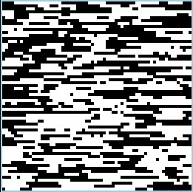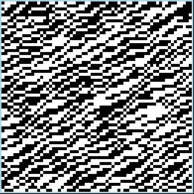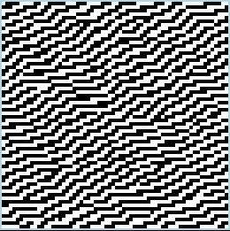

1. Ising model 3

— Q5 Which image minimizes the overall energy for this model ?

— Q6 Change β and give it a negative value. Describe the result and justify it.

We now work in 8-neighborhood, but still with cliques of order 2 (non-isotropic this

time).

Figure 3 – Image A, B, C, D (de gauche ` a droite)

For each of these images, propose the clique potentials that allow us to obtain these

realizations. Initially all clique potentials are zero.

— Image A : there is only one clique potential of order 2 which is -1.

— Image B : in addition to the previous one, there is a clique potential of order 2 which

is 1. Indicate which one.

— Image C : in addition to the 2 previous ones, there is a clique potential of order 2

which is -1. Indicate which one.

— Image D : in addition to the 3 previous ones, there is a second order clique potential

which is +1. Indicate which one.

— Q8 Propose the clique potentials that allow us to obtain these realizations

Potential horiz. horiz. vertical vertical diagonal diagonal diagonal diagonal

π π 3π 3π

(+ )4 (+ )4 (+ )4 (+ )4

Vc (0,1) Vc (0,0) Vc (0,1) Vc (0,0) Vc (0,1) Vc (0,0) Vc (0,1) Vc (0,0)

Vc (1,0) Vc (1,1) Vc (1,0) Vc (1,1) Vc (1,0) Vc (1,1) Vc (1,0) Vc (1,1)

Image A

Image B

Image C

Image D

Modify your program to obtain these results (you can copy and paste the previous cells).

1. Ising model 4

Q9 Modify your program to deﬁne an Ising model with diagonal attractive potentials

only (the other potentials are zero). It means that this model encourages similar labels

(either 0 or 1) for neighboring pixels in the diagonal directions (π/4 or 3π/4 directions).

Describe and comment on the result.